**A**

**PROJECT REPORT**

**ON**

**HELPDESK TICKETING SYSTEM**

BACHELOR’S OF SCIENCE

IN

COMPUTER SCIENCE

**SUBMITTED BY**

**NEHA SAPKAL**



**S.K. COLLEGE OF SCIENCE AND COMMERCE,**

**PLOT NO.31, SEC.25, SEAWOODS , NAVI MUMBAI – 400706**

**2024-25**

**A**

**PROJECT REPORT**

**ON**

**HELPDESK TICKETING SYSTEM**

BACHELOR’S OF SCIENCE

IN

COMPUTER SCIENCE

**SUBMITTED BY**

**NEHA SAPKAL**

PROJECT GUIDE

MRS SHWETA PATIL

**S.K. COLLEGE OF SCIENCE AND COMMERCE,**

**PLOT NO.31, SEC.25, SEAWOODS , NAVI MUMBAI - 400706**

**2024-25**

**ABSTRACT**

A Help Desk Ticketing System is a software solution designed to streamline IT support and customer service by managing and tracking user-reported issues, service requests, and inquiries. This project aims to develop an efficient, user-friendly, and automated ticketing system that enhances communication between users and support teams while improving issue resolution time.

The system allows users to submit tickets detailing their issues, categorize them based on priority and department, and track their progress until resolution. It incorporates key features such as automated ticket assignment, status updates, notifications, and a knowledge base for self-service troubleshooting. Additionally, an admin panel provides insights through analytics and reporting, helping organizations optimize their support operations.

This project will be developed using modern web technologies, ensuring a responsive and secure platform for both users and administrators. The Help Desk Ticketing System ultimately enhances efficiency, reduces response time, and improves overall user satisfaction by providing a structured approach to issue management.

**ACKNOWLEDGEMENT**

I would like to express my special thanks of gratitude to my project guide **Ms Shweta Patil** for their guidelines and support in making my project successful.

I am very thankful to our principal **Dr. Swati Vitkar**  for their kind cooperation in completion of my project.

I am also grateful to **Mrs. Vrushali Ghatpande** , head of department for being very much resourceful, kind and helpful. And also thankful for their positive attitude, time and efforts she provided to us. Your useful advices gives us confidence to do project successfully.

I also wish to thanks our lab assistant and all my friends and entire **computer department** who helped me in completion of my project.

Last but not the list I would like to thank my family without whose support , motivation and encouragement it would not have been possible.

**PREFACE**

It gives me great pleasure to present the project on “**HELPDESK TICKETING SYSTEM**” prepared sincerely, punctually and with utmost efforts.

The contents of this book are presented into many chapters, in order to ease reading. The project has been illustrated with precise data elucidated with precise data elucidated with neat Use Case Diagram and Activity Diagram that simplify the understanding of the project. The project includes the software development tools like Apache, PHP, MYSQL.

Meticulous care has been taken to make this project perfect and useful in every respect.

**NEHA SAPKAL**

**DECLARATION**

I the undersigned **Miss. Neha sapkal** hereby, declare that the work embodied in this project work titled **“HELPDESK TICKETING SYSTEM”** forms my own contribution to the research work carried out under the guidance of **Mrs Shweta patil** is a result of my own research work and has not been previously submitted to any other University for any other Degree/ Diploma to this or any other University.

Wherever reference has been made to previous works of others, it has been clearly indicated as such and included in the bibliography.

I will abide and take all responsibility of all issues related to plagiarism/self-plagiarism mentioned under UNIVERSITY GRANTS COMMISSION (PROMOTION OF ACADEMIC INTEGRITY AND PREVENTION OF PLAGARISM IN HIGHER EDUCATIONAL INSTITUTIONS) REGULATIONS, 2021.

I, here by further declare that all information of this document has been obtained and presented in accordance with academic rules and ethical conduct.

Submitted by Certified by

Neha Sapkal



**INDEX**

|  |  |
| --- | --- |
| INDEX | TOPIC |
| 1 | **PRELIMINARY INVERTIGATION** |
|  | a. INTRODUCTION |
|  | b. DEVELOPMENT TOOLS |
|  | c. FEATURES |
|  | d. LIMITATIONS |
|  | e. DESCRIPTIONS SYSTEM |
| 2 | **SYSTEM REQUIREMENTS** |
|  | a. SOFTWARE REQUIREMENTS |
|  | b. HARDWARE REUIREMENRTS |
| 3 | **SYSTEM ANALYSIS** |
|  | a. ER-DIAGRAM |
| 4 | **SYSTEM CODING** |
|  | a. VALIDATION CODE |
|  | b. DATA SET |
| 5 | **SYSTEM DESIGN** |
| 6 | **FUTURE ENHANCEMENT** |
| 7 | **CONCLUSION** |
| 8 | **REFERENCES AND BIBLIOGRAPHY** |

1. **PRELIMINARY INVERTIGATION**

**INTRODUCTION**

In today's fast-paced business environment, efficient customer support is crucial for maintaining customer satisfaction and operational efficiency. A Help Desk Ticketing System is a digital platform designed to streamline issue resolution by organizing, tracking, and managing customer or internal support requests. It enables businesses to categorize and prioritize tickets, assign them to the appropriate teams, and monitor their status until resolution.

This project aims to develop a user-friendly Help Desk Ticketing System that enhances communication between users and support teams, reduces response times, and ensures accountability. By integrating features such as automated ticket assignment, real-time notifications, and a knowledge base, the system improves problem resolution efficiency. This introduction outlines the significance of a Help Desk Ticketing System, its benefits, and its impact on business operations and customer service quality.

**DEVELOPMENT TOOLS**

**FRONT-END :** PHP

**BACK-END:** PHP,MYSQL Workbench(Database)

**OPERATING SYSTEM :** Windows 11

**FEATURES**

**1**. Ticket Creation – Users can submit support requests.

**2**. Automated Ticket Assignment – Assigns tickets to relevant agents.

**3**. Ticket Prioritization – Categorizes tickets by urgency.

**4**. Multi-Channel Support – Accepts requests via email, chat, phone, etc.

**5**. Status Tracking – Monitors ticket progress in real time.

**6**. Knowledge Base Integration – Provides self-service support options.

**LIMITATIONS**

1. High Initial Setup Cost – Requires investment in software and infrastructure.

2. User Training Needed – Staff and users must learn the system

3. Limited Customization – May not fully meet specific business needs.

4. Scalability Issues – Some systems struggle with high ticket volumes.

5. Response Time Dependency – Resolution speed depends on agent availability.

6. Internet Dependency – Cloud-based systems require stable connectivity.

**DESCRIPTION OF THE SYSTEM**

The **Helpdesk Ticketing System** aims to enhance the efficiency of managing courier operations, including package tracking, delivery scheduling, and customer service. It provides a comprehensive platform for handling courier tasks, from package pickup to final delivery, and offers real-time visibility into the status of deliveries

Key Features:

1. Use MYSQL database which is one of the best database.
2. Use of password protection.
3. All data can get entered easily.
4. It helps to manage and track tickets efficiently.
5. It helps to show the detailed report about tickets and support.
6. It can give you details just by using tracking id.

By implementing these features and adhering to the requirements, the Helpdesk Ticketing System will significantly improve the efficiency and effectiveness of Ticketing operations, benefiting both the company and its customers.

1. **SYSTEM REQUIREMENTS**
2. **SOFTWARE REQUIREMENTS**

* Apache And Mysql Xampp
* Any operating system

1. **HARDWARE REUIREMENRTS**

* Any laptop or PC with specific software.

1. **SYSTEM ANALYSIS**

**1.ER Diagram**

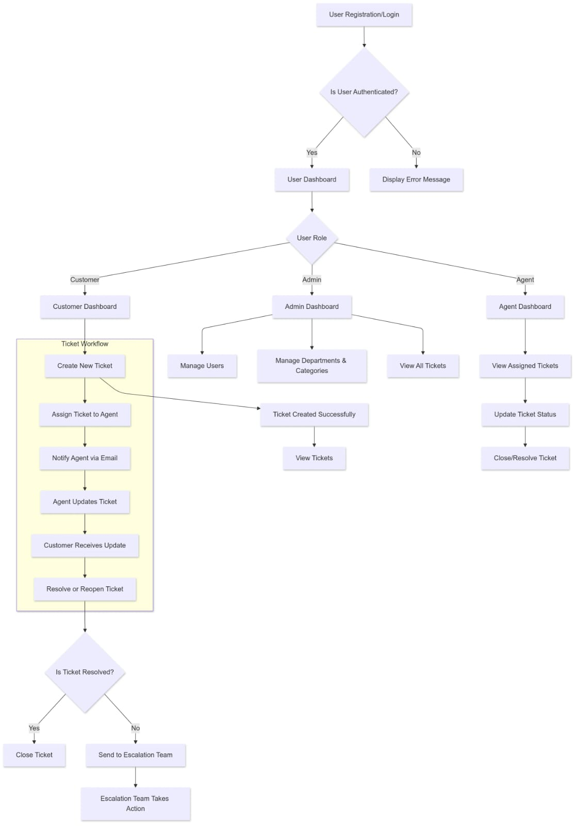

1. **SYSTEM DESIGN**

1.Login page

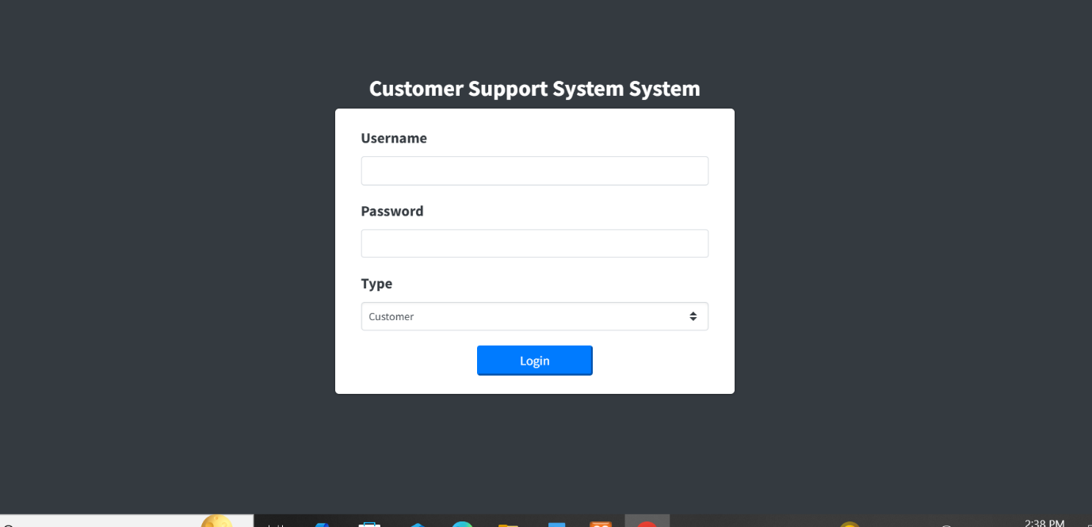

2. Home Page

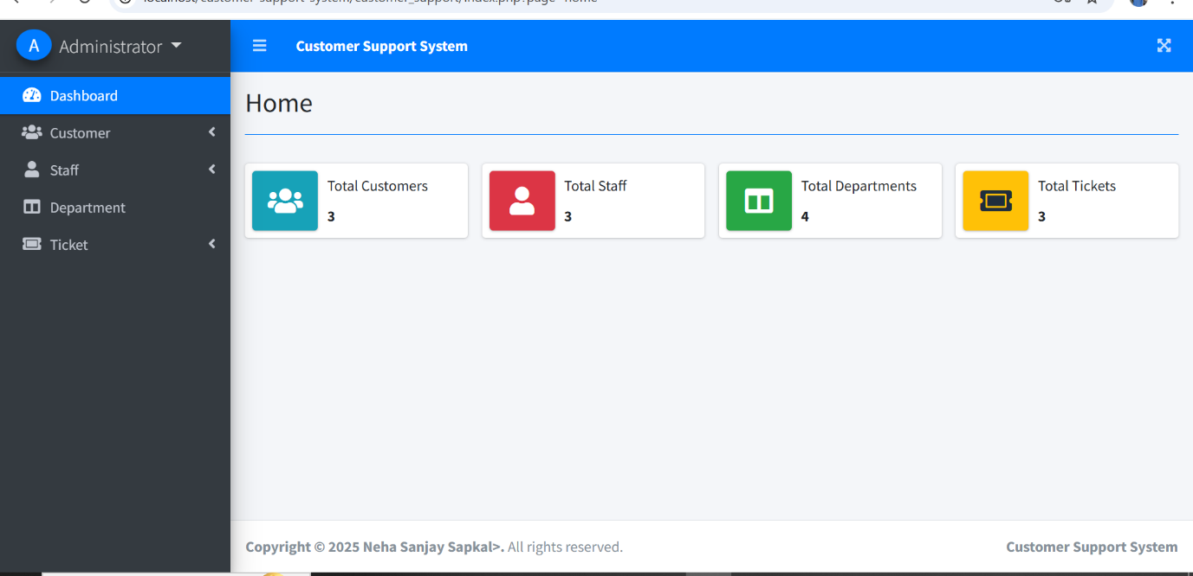

3.For adding new Customer information.

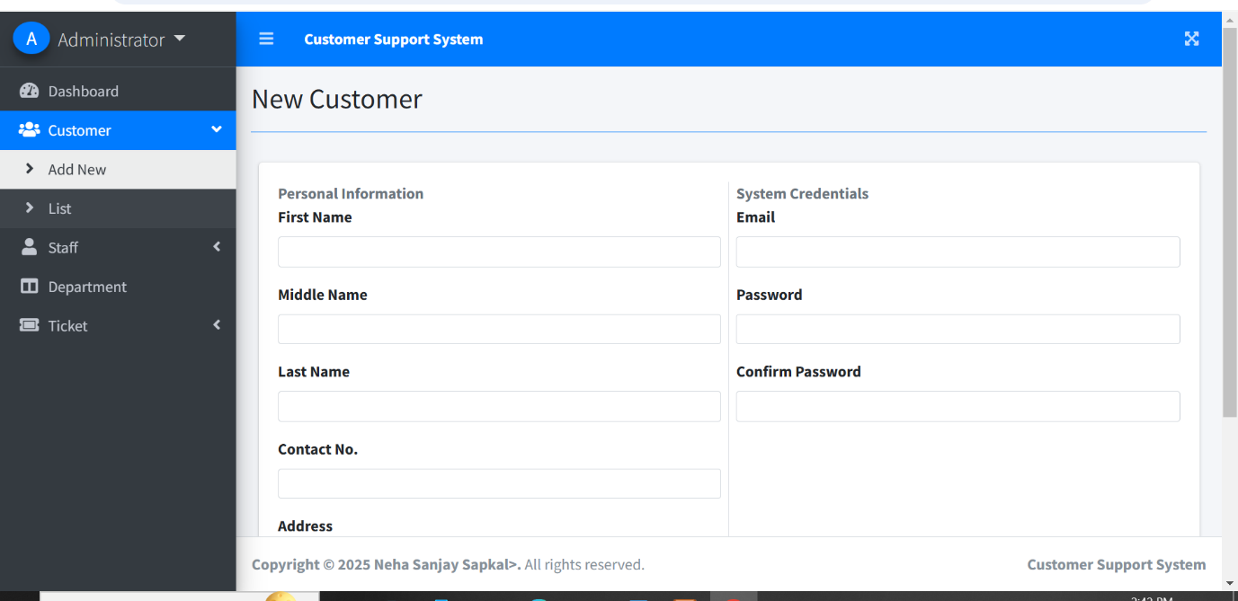

4.For viewing list of all Customers.

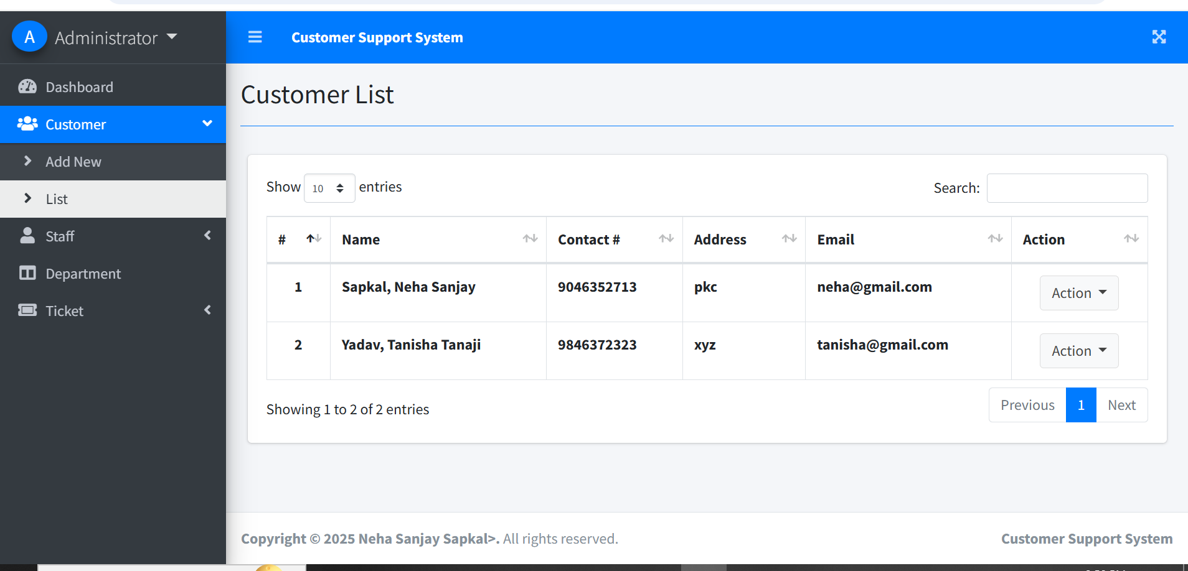

5.Page for adding new staff.

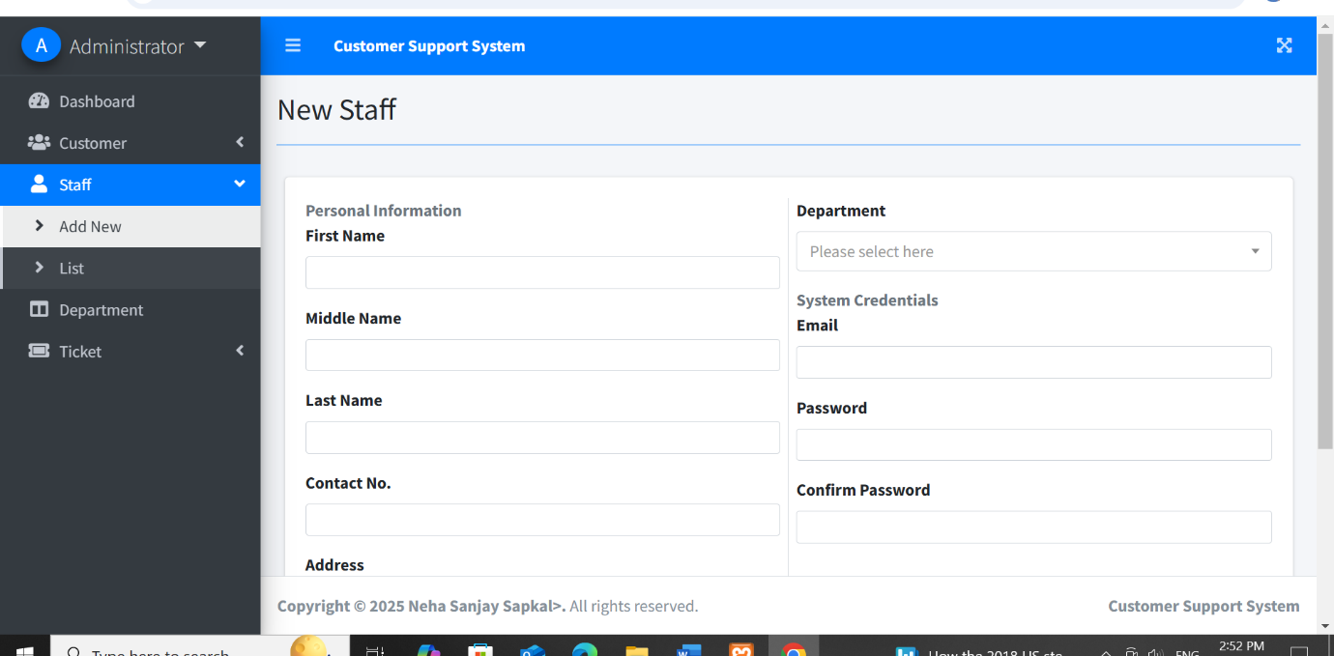

6.For viewing staff list.

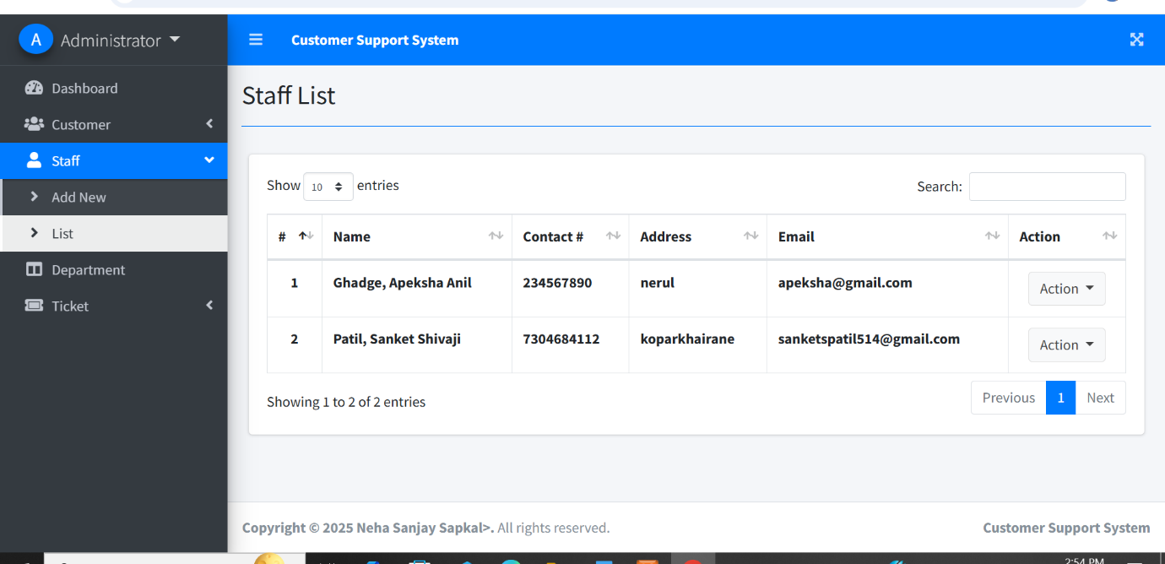

7.For viewing list of Departments

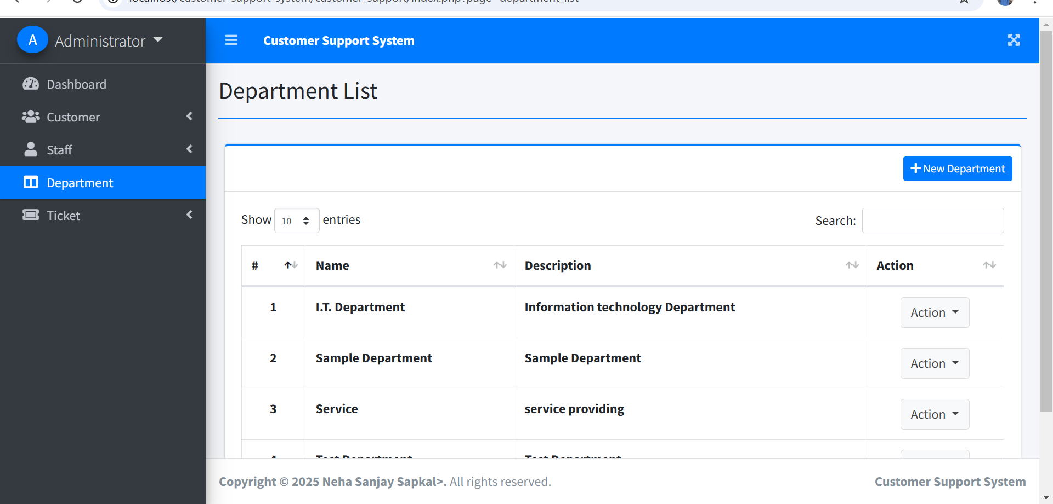

8.Page to add new ticket.

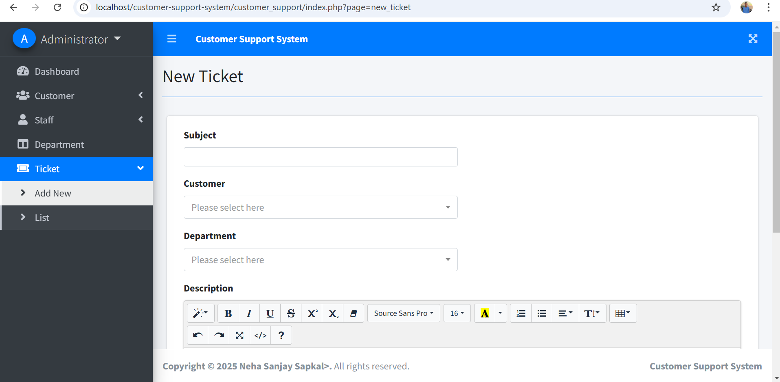

9.For viewing the list of tickets.

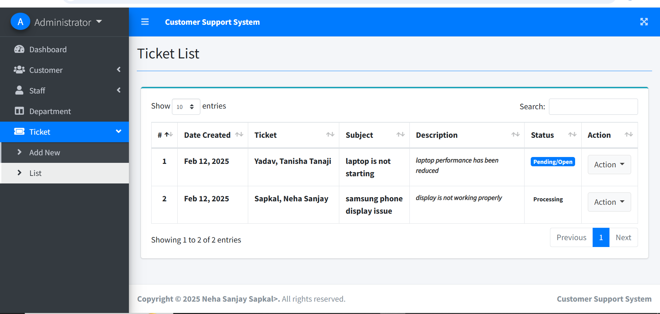

1. **VALIDATION CODE**

**1.Validation part in adding new users for First name, Last name, Email and Password.**

**<!DOCTYPE html>**

**<html>**

**<body>**

**<script type="text/JavaScript" src="js/sha512.js"></script>**

**<script type="text/JavaScript" src="js/forms.js"></script>**

**<!-- Registration form to be output if the POST variables are not**

**set or if the registration script caused an error. -->**

**<h1 style="margin:.1em .5em 0 .5em; color:white; font-size:56px">Ticketdesk</h1>**

**<div class="panel panel-default" style="margin:2em;">**

**<div class="panel-heading">User Registration</div>**

**<div class="panel-body">**

**<?php**

**if (!empty($error_msg)) {**

**echo $error_msg;**

**}**

**if (!empty($success)) {**

**echo $success;**

**}**

**?>**

**<div id="regForm">**

**<ul>**

**<li>Usernames may contain only digits, upper and lowercase letters and underscores</li>**

**<li>Emails must have a valid email format</li>**

**<li>Passwords must be at least 6 characters long</li>**

**<li>Passwords must contain**

**<ul>**

**<li>At least one uppercase letter (A..Z)</li>**

**<li>At least one lowercase letter (a..z)</li>**

**<li>At least one number (0..9)</li>**

**</ul>**

**</li>**

**<li>Your password and confirmation must match exactly</li>**

**</ul>**

**<form action="<?php echo esc_url($_SERVER['PHP_SELF']); ?>" method="post" name="registration_form">**

**<input type='text' class="form-control" placeholder="Username" aria-describedby="basic-addon1"  name='username' id='username' /><br>**

**<input type="text" class="form-control" placeholder="Email" aria-describedby="basic-addon1" name="email" id="email" /><br>**

**<input type="password" name="password" id="password" class="form-control" placeholder="Password" aria-describedby="basic-addon1"/><br>**

**<input type="password" name="confirmpwd" id="confirmpwd" class="form-control" placeholder="Confirm Password" aria-describedby="basic-addon1" /><br>**

**<input type="button" name="registerBtn" id="registerBtn" class="btn btn-primary" value="Register" onclick="return regformhash(this.form, this.form.username, this.form.email, this.form.password, this.form.confirmpwd);" />**

**</form>**

**<p>Return to the <a href="index.php">login page</a>.</p>**

**</div>**

**</div>**

**</div>**

**</body>**

**</html>**

**6.FUTURE ENHANCEMENT**

* For any system that is developing, there is always way for more development.
* The Helpdesk Ticketing System has a lot of enhancement options.
* Some of future enhancement we can do in future version are as follows :

1. In future more features may be added category-wise.
2. Can also add option so that users can themself select the customer support centre and the executive

**iii.**Can also add online payment for ticket charges.

**7.CONCLUSION**

* It has user-friendly interface so user can use system easily with the basic knowledge of computer.
* This software will help admin for storing data easily.
* Proper testing has been done by developer.
* This software is secure as it has proper authentication system .
* It can keep all your data stored for a long duration.
* It will give you all the data when you need it within some time.

**8.REFERENCES AND BIBLIOGRAPHY**

* [**www.google.com**](http://www.google.com)
* [**www.youtube.com**](http://www.youtube.com)